
ASSIGNMENT NO 3
231678_AROOBA SHEHZADI

MAM SARA IBRAHIM
SOFTWARE ENGINEERING
BSCS 4B

- UML Class Diagram – HomeToHome Service Booking System:

This class diagram represents the static structure of a HomeToHome Service Booking System, which allows users to book home services (like cleaning, plumbing, etc.), and enables admins to manage workers, services, and users.

Classes:
- Person (Superclass)
- Attributes: firstName, lastName, email, password
- Method: login()
- Serves as a base class for Admin, User, and Worker, demonstrating inheritance (generalization).

- Admin (inherits Person)
- Manages services and workers.
- Methods: registerWorker(), approveWorker(), manageServices(), replyToMessage() etc.

- User (inherits Person)
- Can register, book services, send messages, and submit feedback or reviews.
- Methods: register(), bookService(), sendMessage(), giveFeedback() etc.

- Worker (inherits Person)
- Executes services for users and can view assigned bookings and reviews.
- Attributes: designation, experience, skills, approved etc.
- Methods: acceptBooking(), markCompleted() etc.

- Service
- Represents available services that can be booked by users.
- Attributes: name, description, price, category
- Methods: createService(), editService()

- Booking
- Handles service booking data.
- Attributes: date, time, status
- Methods: updateStatus(), assignWorker()

- Review and Feedback
- Allow users to provide reviews for workers and feedback for the system.

- ContactMessage
- Enables user-to-admin communication via messages and replies.

Relationships:
- Inheritance: Admin, User, and Worker inherit from Person.

- Association:

- User books Service via Booking.
- Worker is assigned to Booking.
- User submits Review and Feedback.
- Admin replies to ContactMessage.

Multiplicity:
- One User can have multiple Bookings (1..*).
- One Booking can include multiple Reviews (0..*).
- One Admin manages multiple Services.
This diagram captures the fundamental structure and relationships of the system and supports its key operations such as service management, user registration, booking, and feedback handling.

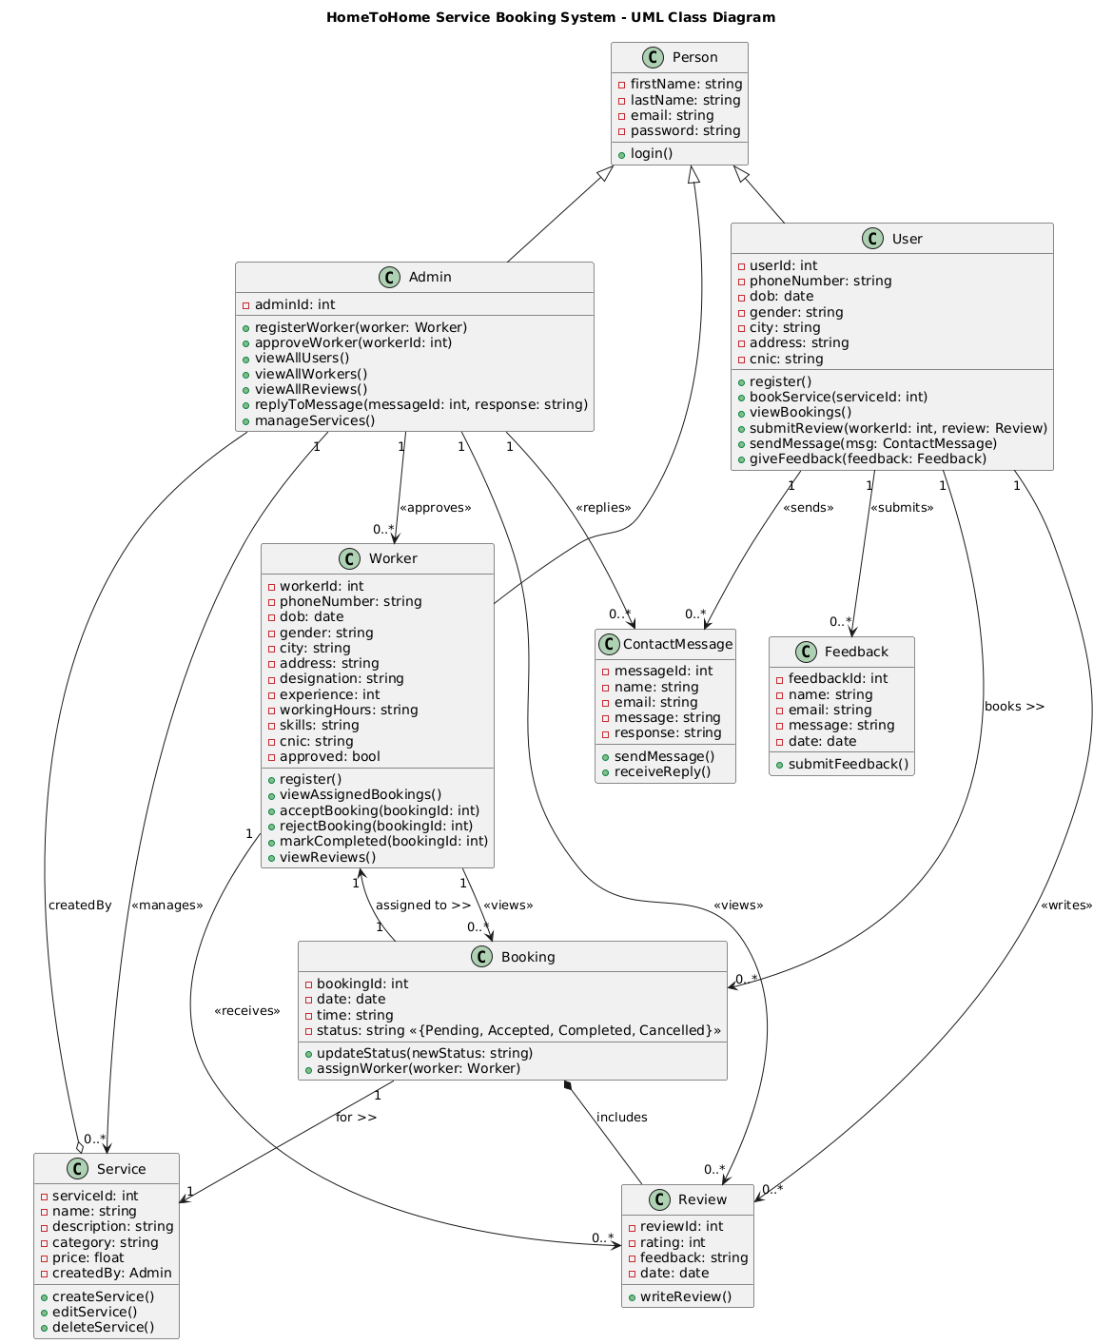

- Sequence Diagram:
Service Booking Sequence in HomeToHome Web Application:
The sequence diagram visually represents the step-by-step flow of a service booking operation in the HomeToHome web application, involving four key components: User, UI (HomeToHome Interface), Service: Database, and Worker. Here’s how the process unfolds:

Step 1: Search for Service:

- The user enters the required service type.
- UI sends a request to the database service to find matching services.
- The database returns a list of relevant services.
- UI displays the available services and workers to the user.

Step 2: Select and Book a Worker:

- The user selects a worker by ID.
- The user clicks the "Book" button, triggering the UI to send the booking request (including service, worker, and payment details) to the backend.

Step 3: Worker Response and Confirmation:

- The backend sends the request to the selected worker.
- The worker accepts the service request.
- A booking confirmation is generated by the backend.
- The confirmation is passed back through the UI and shown to the user.

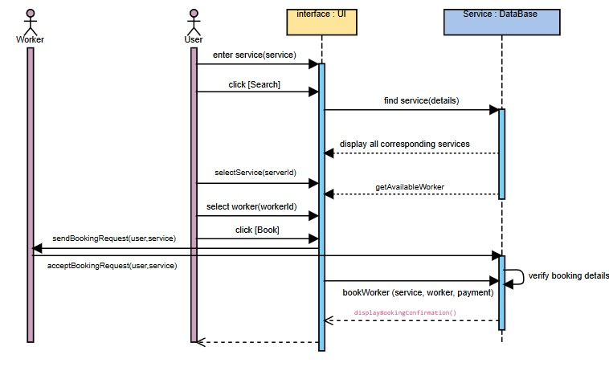

- Activity Diagram (with swimlanes):
This activity diagram represents the workflow of a FixIt Web Application using four swimlanes based on system actors: Customer, Worker, Admin, and System . It begins with the customer registering and browsing available services. Once a service is booked, the system automatically matches the request with a suitable worker based on their skills. The worker logs in, views matching job requests, and decides whether to accept or reject the booking.
The Admin is responsible for registering and approving new workers, viewing users and service requests, and monitoring reviews. The System handles automated tasks such as booking-worker matching, sending notifications, storing reviews, and managing worker visibility.
Decision nodes are used to check user registration status and booking acceptance. The diagram also shows interactions between swimlanes, such as the system notifying workers after a booking and routing reviews to the admin. It ends after the review is stored in the system, completing the service cycle.

This diagram clearly visualizes the flow of activities, responsibilities of each actor, and the coordination required to deliver a seamless service experience.

